|  |
| --- |
| **PT. BERLIAN SISTEM INFORMASI** |
| **Operating Lease – Calculation Process** |
| **USER MANUAL GUIDE** |
|  |
| **VERSION 1.1** |
| **6/28/2016** |

|  |
| --- |
| All material contained in this manual including text, graphics, icons and images contain proprietary and confidential information of PT. Berlian Sistem Informasi and are protected by international intellectual property and other laws. The compilation of all text, graphics, icons and images in this Manual is the exclusive property of PT. Berlian Sistem Informasi. No modification, rental, lease, sale, transmission, distribution, reposting or creation or derivate works based on the material in this Manual is allowed, unless with the express permission of PT. Berlian Sistem Informasi. |

# REVISION HISTORY

|  |  |  |  |
| --- | --- | --- | --- |
| Date | Revision | Description | Author |
| 04/07/2016 | 0.0 | Initial Document | AR. Anggun Cahyaningtyas |
| 05/02/2016 | 0.1 | Update Document after UAT | AR. Anggun Cahyaningtyas |
| 05/04/2016 | 1.0 | 1st Baseline | Grand Zah Putra |
| 06/28/2016 | 1.1 | Update Document after Training | Sabilla Pravita Larassati |

# TABLE OF CONTENT

REVISION HISTORY 2

TABLE OF CONTENT 3

MARKETING MODULE 4

1. Calculation of Operating Lease 4

1.1. Show List of Calculation Record 4

1.2. Filter and Sort Calculation List 6

1.3. Create a new Calculation of Operating Lease 7

1.4. Edit a Draft Document of Calculation 20

1.5. View Detail Calculation of Operating Lease 22

1.6. Print Proposal Report 28

1.7. Print Calculation Attachment Report 31

# MARKETING MODULE

Operating Lease Support System includes Marketing Module features; **Calculation of Operating Lease**, Operating Lease Quotation, Visit Customer Survey, Board of Director Decree / SKD Process, Agreement Information Inquiry, and Complement Document. The Marketing menu of Operating Lease Support System serves as the basic access to marketing module and records of all data. With the marketing menu, you will be able to utilize features of marketing module, including information that will be adjusted through other features of Operating Lease Support System.

Additionally you can enter a record, make changes, and inspect a detail record, and also filter specific records based on columns by writing a keyword on the search field. The features and data contained in your Operating Lease Support System menu are limited by your security and data authorization settings so you may not be able to access all features.

# Calculation of Operating Lease

The Calculation of operating lease is designed to facilitate and maintain the calculation process that had to be done manually before. The system simplifies the calculation process by filling out the input forms. This function is consisting of several information; there are basic product information, basic lease information, cost condition, DSF finance condition, DP information, registration fee, maintenance basic information, maintenance condition and cost, insurance basic information, insurance condition and cost, confirmation of lease cost, profit result, proposal info, person in charge, and additional item for proposal. Although each user can save as draft, save changes, submit, edit and view their respective data. Only authorized user can changes the status (draft, submitted) their information or records by using the system.

Calculation of Operating Lease provides several functions:

1. Create new Calculation of Operating Lease, within save as draft, save changes and submit.
2. View details of calculation information.
3. Filter and sort function.
4. Modify calculation information; keep them up-to-date.
5. Print proposal and calculation report.

## Show List of Calculation Record

At the beginning, user can open calculation of operating lease by clicking the ‘Calculation of Operating Lease (Cash flow Method)’ on the list of marketing module. Once clicked the menus, system will display the Calculation of Operating Lease page. This page may show a calculation list, which is inputted including status that processed by user.

When opening the Calculation of Operating Lease page it may look as following:

1. Navigate to Marketing module and click “Calculation of Operating Lease (Cash flow Method)”.

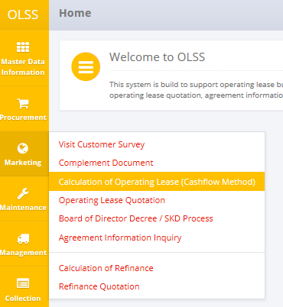

Screen 1: Calculation of Operating Lease (Cash flow Method) Menu

1. System will show Calculation of Operating Lease screen that already recorded in the system. The main page is shown below:

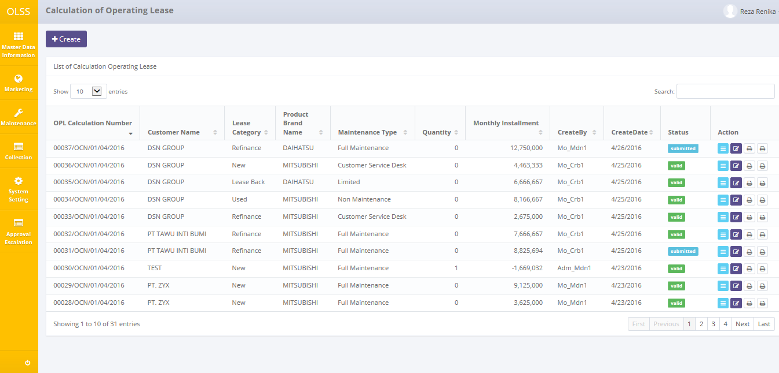

Screen 2: Calculation of Operating Lease

User can see information such as:

OPL Calculation Number, Customer name, Lease Category, Product Brand Name, Maintenance Type, Quantity, Monthly Installment, Created By, Created Date, Status, and Action row.

Calculation statuses are divided into 3 types:

1. 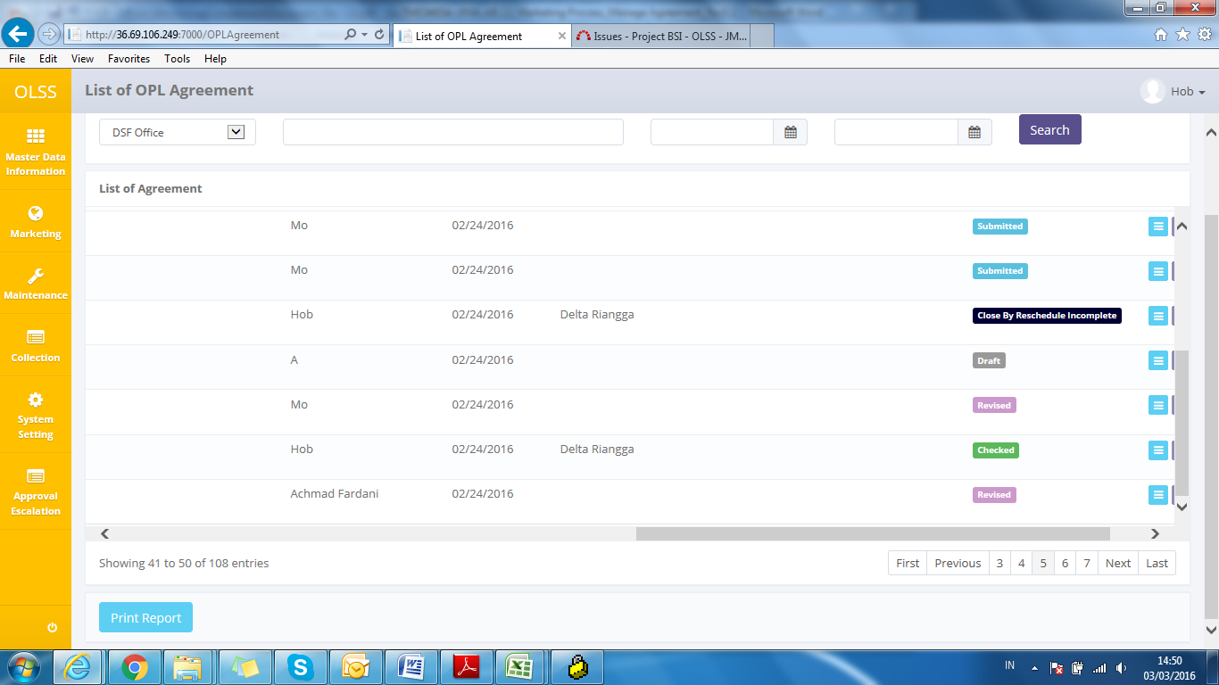, calculation hasn’t been submitted by admin.
2. , calculation has been submitted by admin.
3. , calculation has been used for the next processes (quotation).

On the Calculation of Operating Lease screen, there will be five buttons, which are:

* 1. : On top-left screen, click the button to create a new calculation.
  2. : In the action column, click the button to modify calculation information.
  3.  : In the action column, click the button to view detail of calculation information.
  4. : In the action column, click the button on left to print proposal report.
  5. : In the action column, click the button on right to print calculation attachment report.

## Filter and Sort Calculation List

To filter the records there are three categories as follows:

1. To sort the record alphabetically by column, user can click  on the column title on the table header.
2. User can select the number of records that want to be showed by picking this feature  on the screen. If the records have been filtered based on number, the amount of records that will be shown is the same as the selected number.
3. User can search specific records by entering the keywords on the search field with shown below:



Screen 3: Search Field

## Create a new Calculation of Operating Lease

To create calculation, find and click Create on top of the Calculation of Operating Lease Screen.

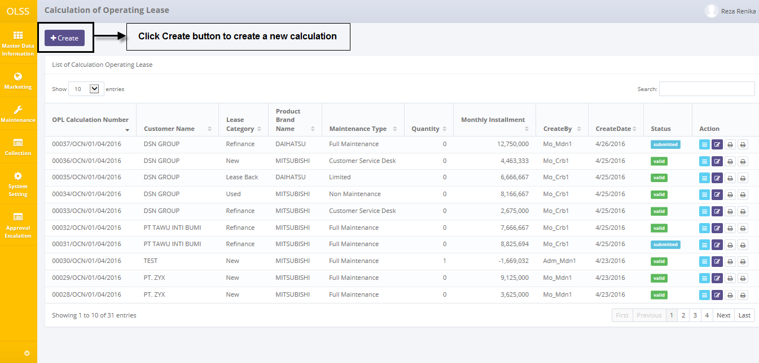

Screen 4: Navigate to Create Calculation of Operating Lease

System will show create calculation screen (Step 1 – Step 6) shown below:

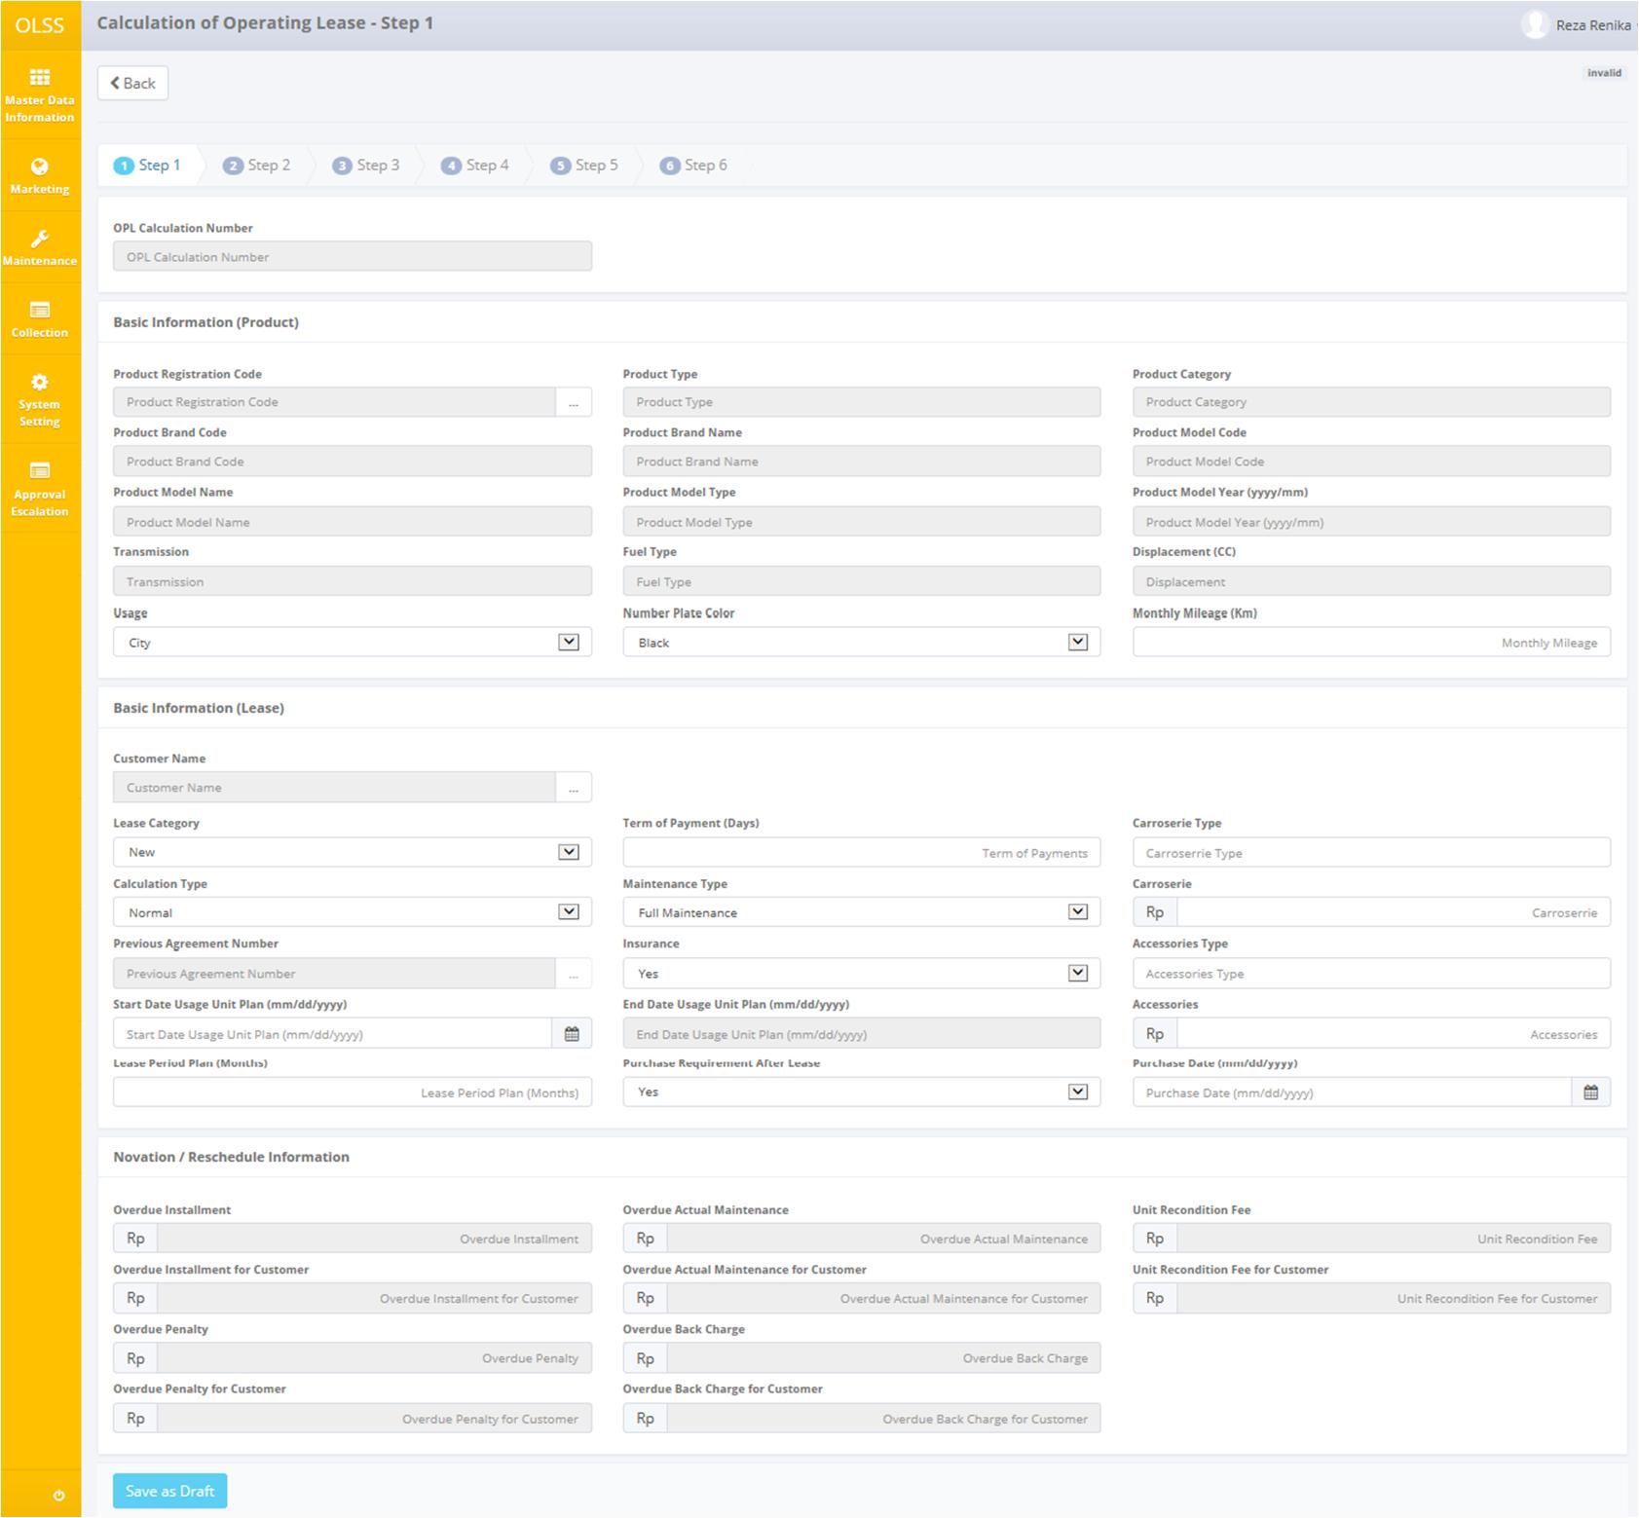

Screen 5: Screen of Calculation Creation– Step 1

Once the calculation creation **Step 1** screen open, user has to fill information on the blank field. The fields are:

1. Basic Information (Product):
   1. Product Registration Code: Select product code. Selecting product code will automatically load up product information (Product Type, Product Category, Product Brand Code, Product Brand Name, Product Model Code, Product Model Name, Product Model Type, Product Model Year, Transmission, Fuel Type, and Displacement).
   2. Usage: pick usage city or site.
   3. Number Plate Color: pick plate color (Black, Yellow, Red, or White).
   4. Monthly Mileage (Km): input estimate monthly mileage in Kilometers.
2. Basic Information (Lease):
   1. Customer Name: select customer name (company).
   2. Lease Category: select a lease category as new, refinance, used, or lease back.
   3. Calculation Type: select normal calculation; reschedule agreement calculation, or novation agreement calculation.
   4. Previous Agreement Number: select agreement number to reference if you pick reschedule or novation agreement in Calculation Type field.
   5. Start Date Usage Unit Plan (mm/dd/yyyy): select start date usage unit plan. The payment due date cannot be on 29th, 30th, or 31st. usually on first week.
   6. Lease Period Plan (Months): input lease period plan in months (24, 36, 48, or 60). Inputting start date usage unit plan and lease period plan will trigger End Date Usage Unit Plan (mm/dd/yyyy).
   7. Term of Payment (Days): input term of payments 14 or 30.
   8. Maintenance Type: pick a maintenance type (Full Maintenance, Limited, Customer Service Desk, or Non Maintenance). If there is no maintenance, then just choose Non Maintenance.
   9. Insurance: pick ‘Yes’ if there is insurance, or ‘No’ if there is no insurance.
   10. Purchase Requirement After Lease: pick purchase requirement after lease Yes or No.
   11. Carroserrie Type: input carroserrie name, for example: box, dump truck, etc.
   12. Carroserrie: input total amount of carroserrie include VAT IN.
   13. Accessories Type: input accessories name, for example: Bluetooth, etc.
   14. Accessories: input total amount of accessories include VAT IN.
   15. Purchase Date (mm/dd/yyyy): Select purchase date. Purchase date cannot be more than Start Date Usage Unit Plan.
3. Novation/Reschedule Information (*active if Calculation Type is reschedule or novation agreement*):
   1. Overdue Installment: input total overdue installment price.
   2. Overdue Installment for Customer: input total overdue installment for customer.
   3. Overdue Penalty: input total overdue penalty price.
   4. Overdue Penalty for Customer: input total overdue penalty for customer.
   5. Overdue Actual Maintenance: input total actual maintenance price.
   6. Overdue Actual Maintenance for Customer: input total actual maintenance for customer.
   7. Overdue Back Charge: input total back charge price.
   8. Overdue Back Charge for Customer: input total back charge for customer.
   9. Unit Recondition Fee: input unit recondition fee.
   10. Unit Recondition Fee for Customer: input unit recondition fee for customer.

After all the fields are filled, you can click ‘Save as Draft’ button on the bottom of the screen. System will save the data and will display ‘Next Step’ button. Click the ‘Next Step’ button to continue the calculation process.

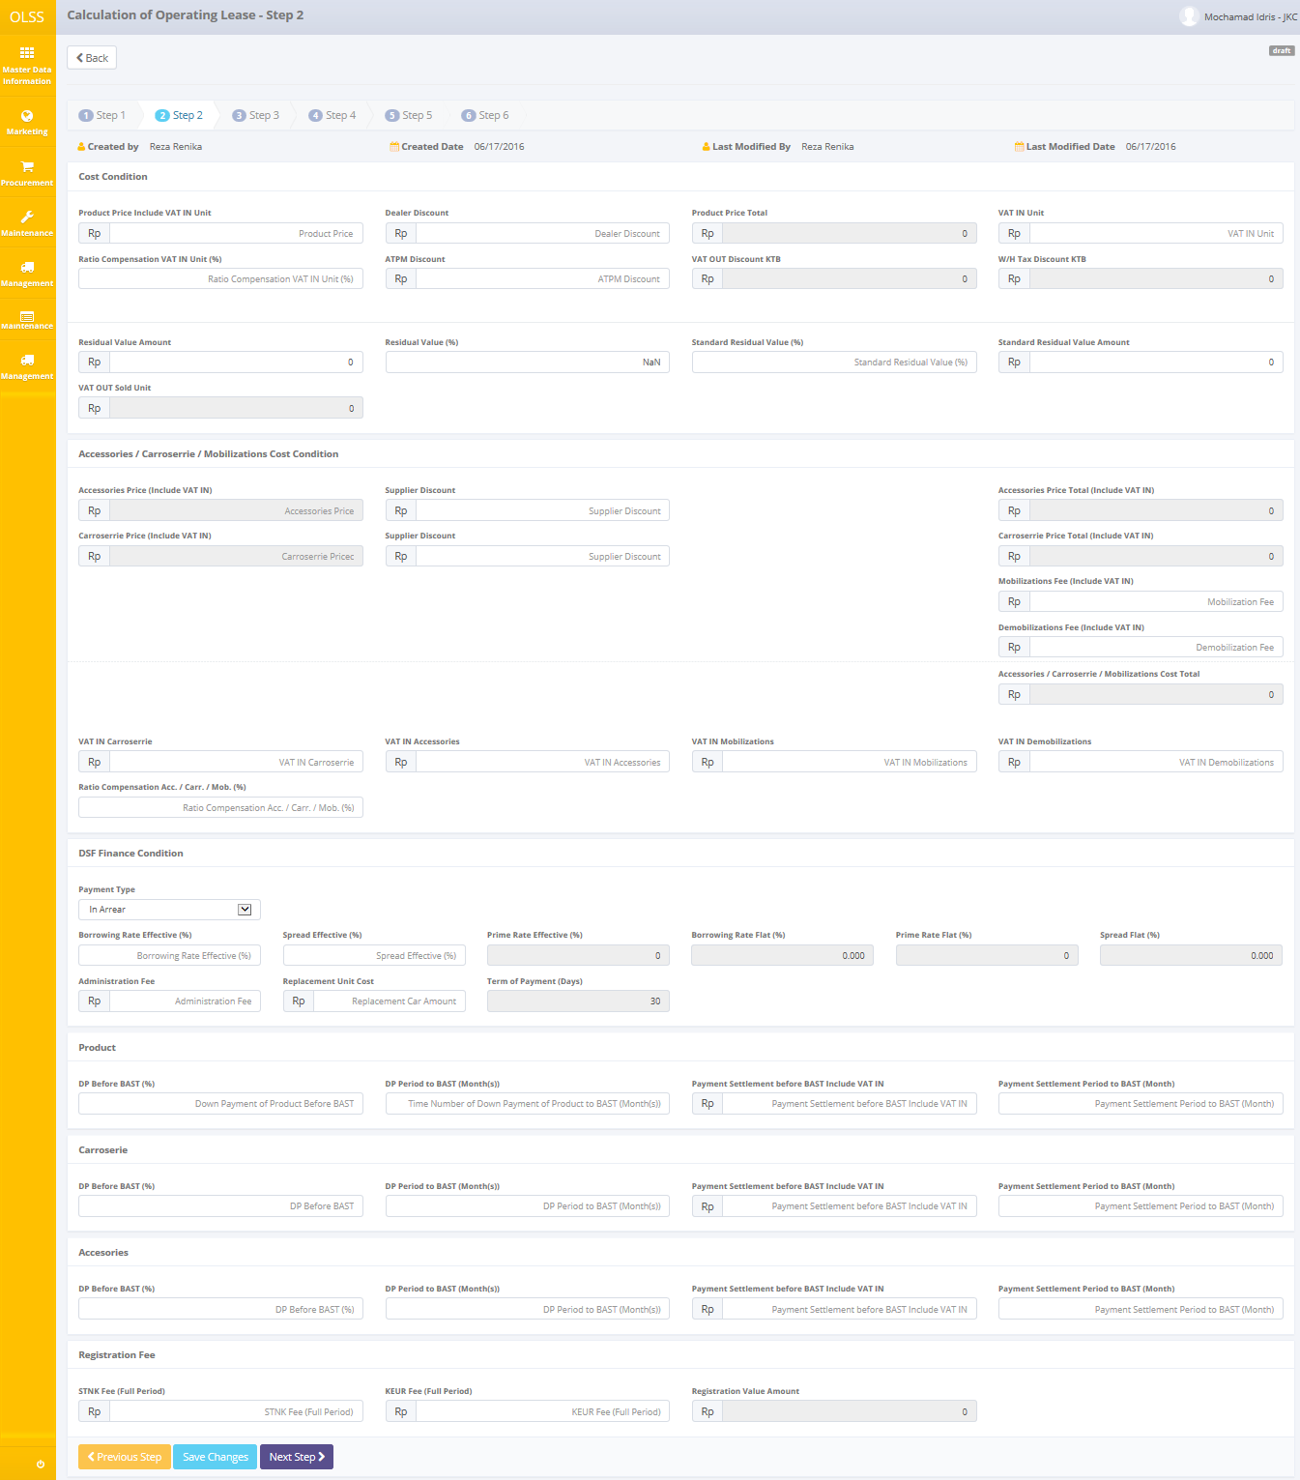

Screen 6: Screen of Create Calculation – Step 2

Once the calculation creation **Step 2** screen open, user has to fill information on the blank field. The fields are:

1. Cost Condition:
   1. Product Price Include VAT IN Unit: input amount for product price unit that include VAT IN.
   2. Dealer Discount: input amount discount from dealer. Dealer discount will reduce amount Product Price Include VAT IN Unit, and the price shown on field Product Price Total.
   3. VAT IN Unit: input tax that included in product price unit.
   4. Ratio Compensation VAT IN Unit (%): input percentage of ratio compensation VAT IN Unit.
   5. ATPM Discount: input amount discount from ATPM (KTB, etc). ATPM Discount will trigger field VAT OUT Discount KTB (10% from ATPM Discount) and field W/H Tax Discount KTB (15% from ATPM Discount).
   6. Residual Value Amount: input amount of residual value. This field will automatically load up field Residual Value (%) and VAT OUT Sold Unit.
   7. Standard Residual Value Amount: input standard residual value amount (if any). This field will automatically load up for field Standard Residual Value (%).
2. Accessories/Carroserrie/Mobilizations Cost Condition:
   1. Supplier Discount (*for accessories*): input amount discount of accessories from supplier if any.
   2. Supplier Discount (*for carroserrie*): input amount discount of carroserrie from supplier if any.
   3. Mobilizations Fee (Include VAT IN): input amount mobilizations fee that include tax.
   4. Demobilizations Fee (Include VAT IN): input amount demobilizations fee that include tax.
   5. VAT IN Carroserrie: input amount tax that include in total price carroserrie.
   6. VAT IN Accessories: input amount tax that include in total price accessories.
   7. VAT IN Mobilizations: input amount tax that include in mobilizations fee.
   8. VAT IN Demobilizations: input amount tax that include in demobilizations fee.
   9. Ratio Compensation Acc./Carr./Mob. (%): input percentage of ratio compensation for accessories, carroserrie, and mobilizations.
3. DSF Finance Condition:
   1. Payment Type: pick the payment type In Arrear or In Advance.
   2. Borrowing Rate Effective (%): fill with percentage of borrowing rate effective.
   3. Spread Effective (%): fill with percentage of spread effective. Filling Borrowing Rate Effective and Spread Effective will trigger for field Prime Rate Effective (%), Borrowing Rate Flat (%), Prime Rate Flat (%), and Spread Flat (%).
   4. Administration Fee: input amount of administration fee.
   5. Replacement Unit Cost: input total replacement car amount.
4. Product:
   1. DP before BAST (%): input percentage of Down Payment unit before BAST.
   2. DP Period to BAST (Month(s)): input different months from down payment unit to delivery unit.
   3. Payment Settlement before BAST Include VAT IN: input payment settlement unit amount before BAST and include tax/VAT IN.
   4. Payment Settlement Period to BAST (Month): input different month from payment settlement unit to delivery unit.
5. Carroserie:
   1. DP before BAST (%): input percentage of Down Payment carroserrie before BAST.
   2. DP Period to BAST (Month(s)): input different months from down payment carroserrie to delivery carroserrie.
   3. Payment Settlement before BAST Include VAT IN: input payment settlement carroserrie amount before BAST and include tax/VAT IN.
   4. Payment Settlement Period to BAST (Month): input different month from payment settlement carroserrie to delivery carroserrie.
6. Accessories:
   1. DP before BAST (%): input percentage of Down Payment accessories before BAST.
   2. DP Period to BAST (Month(s)): input different months from down payment accessories to delivery accessories.
   3. Payment Settlement before BAST Include VAT IN: input payment settlement accessories amount before BAST and include tax/VAT IN.
   4. Payment Settlement Period to BAST (Month): input different month from payment settlement accessories to delivery accessories.
7. Registration Fee:
   1. STNK Fee (Full period): input amount of STNK fee for full period.
   2. KEUR Fee (Full Period): input amount of KEUR fee for full period. Registration Value Amount is the sum of STNK Fee and KEUR Fee.

After all the fields are filled, you can click ‘Save as Draft’ button on the bottom of the screen. System will save the data and will display ‘Next Step’ button. Click the ‘Next Step’ button to continue the calculation process.

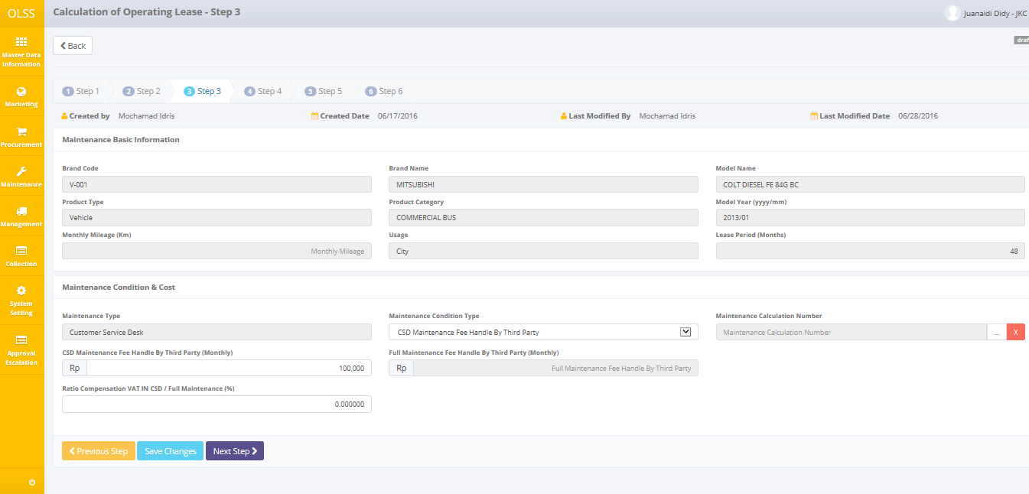

Screen 7: Screen of Create Calculation – Step 3

Once the calculation creation **Step 3** screen open, user has to fill information on the blank field. This screen just open if maintenance type that chooses on Step 1 is Full Maintenance, or Customer Service Desk. The blank fields are:

1. Maintenance Condition & Cost:
   1. Maintenance Condition Type: pick a maintenance condition type
      1. If you choose CSD Maintenance Fee Handle by Third Party you just can input field Maintenance Calculation Number or CSD Maintenance Fee Handle by Third Party (Monthly).
      2. If you choose Full Maintenance Fee Handle by Third Party you just can input field Full Maintenance Fee Handle by Third Party (Monthly).
      3. If you choose CSD Maintenance Fee Handle by DSF or Full Maintenance Fee Handle by DSF you just can input field Maintenance Calculation Number.
   2. Maintenance Calculation Number: select maintenance calculation number that already processed in **Maintenance Calculation Budget** menu.

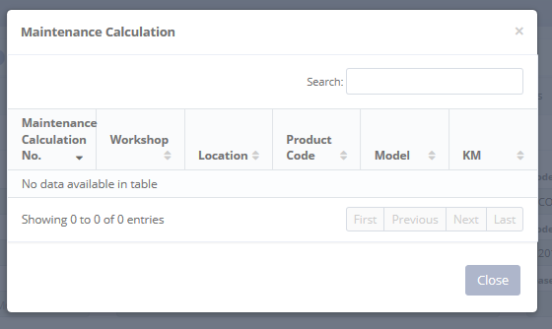

Screen : Maintenance Calculation Number Selection

* 1. CSD Maintenance Fee Handle by Third Party (Monthly): input amount of CSD maintenance fee that handled by Third Party every month.
  2. Full Maintenance Fee Handle by Third Party (Monthly): input amount of Full maintenance fee that handled by Third Party every month.
  3. Ratio Compensation VAT IN CSD/Full Maintenance (%): fill with percentage of ratio compensation maintenance that handled by Third Party.

After all the fields are filled, you can click ‘Save as Draft’ button on the bottom of the screen. System will save the data and will display ‘Next Step’ button. Click the ‘Next Step’ button to continue the calculation process.

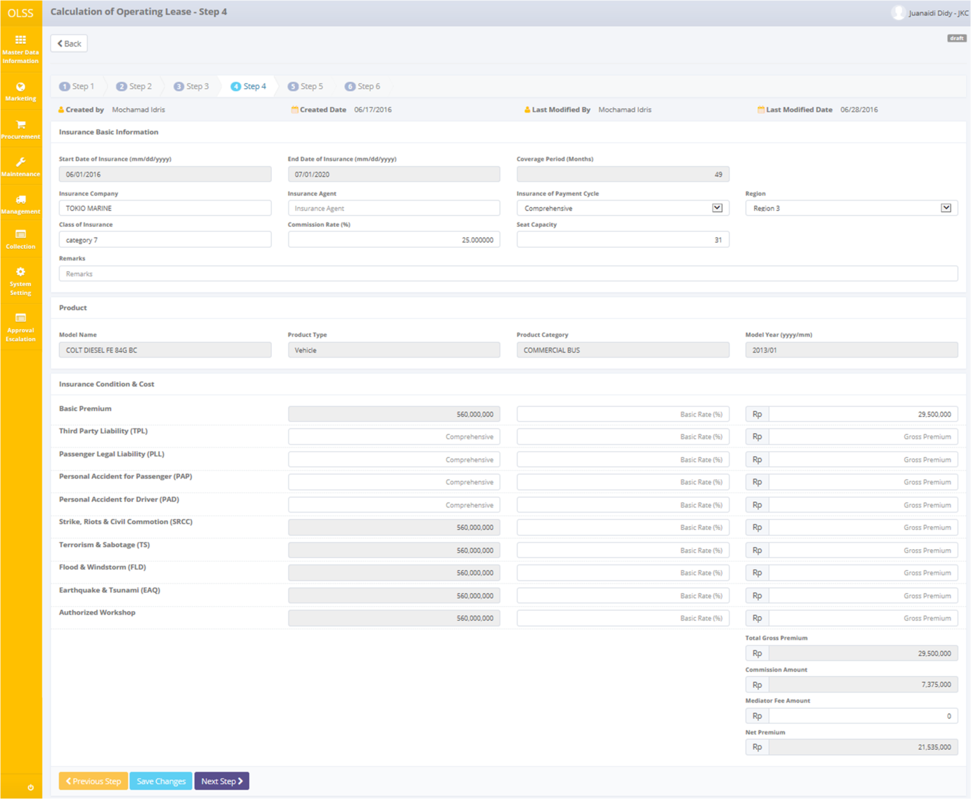

Screen 9: Screen of Create Calculation – Step 4

Once the calculation creation **Step 4** screen open, user has to fill information on the blank field. This screen is available if on Step 1 you choose Yes for Insurance. The blank fields are:

1. Insurance Basic Information:
   1. Insurance Company: fill with insurance company name.
   2. Insurance Agent: fill with insurance agent name.
   3. Insurance of Payment Cycle: pick insurance of payment cycle Yearly (once a year) or Comprehensive (once before start date usage unit).
   4. Region: pick a region.
   5. Class of Insurance: input class of insurance.
   6. Commission Rate (%): input percentage of commission rate for the insurance.
   7. Seat Capacity: input seat capacity that getting the insurance.
   8. Remarks: fill any information.
2. Insurance Condition & Cost:
   1. Basic Premium: input amount comprehensive, percentage basic rate, and gross premium for Basic Premium if any.
   2. Third Party Liability (TPL): input amount comprehensive, percentage basic rate, and gross premium for Third Party Liability if any.
   3. Passenger Legal Liability (PLL): input amount comprehensive, percentage basic rate, and gross premium for Passenger Legal Liability if any.
   4. Personal Accident for Passenger (PAP): input amount comprehensive, percentage basic rate, and gross premium for Personal Accident for Passenger if any.
   5. Personal Accident for Driver (PAD): input amount c comprehensive, percentage basic rate, and gross premium for Passenger Legal Liability if any.
   6. Strike, Riots, & Civil Commotion (SRCC): input amount comprehensive, percentage basic rate, and gross premium for Personal Accident for Driver if any.
   7. Terrorism & Sabotage (TS): input amount comprehensive, percentage basic rate, and gross premium for Terrorism and Sabotage if any.
   8. Flood & Windstorm (FLD): input amount comprehensive, percentage basic rate, and gross premium for Flood and Windstorm if any.
   9. Earthquake & Tsunami (EAQ): input amount comprehensive, percentage basic rate, and gross premium for Earthquake and Tsunami if any.
   10. Authorized Workshop: input amount comprehensive, percentage basic rate, and gross premium for Authorized Workshop if any.

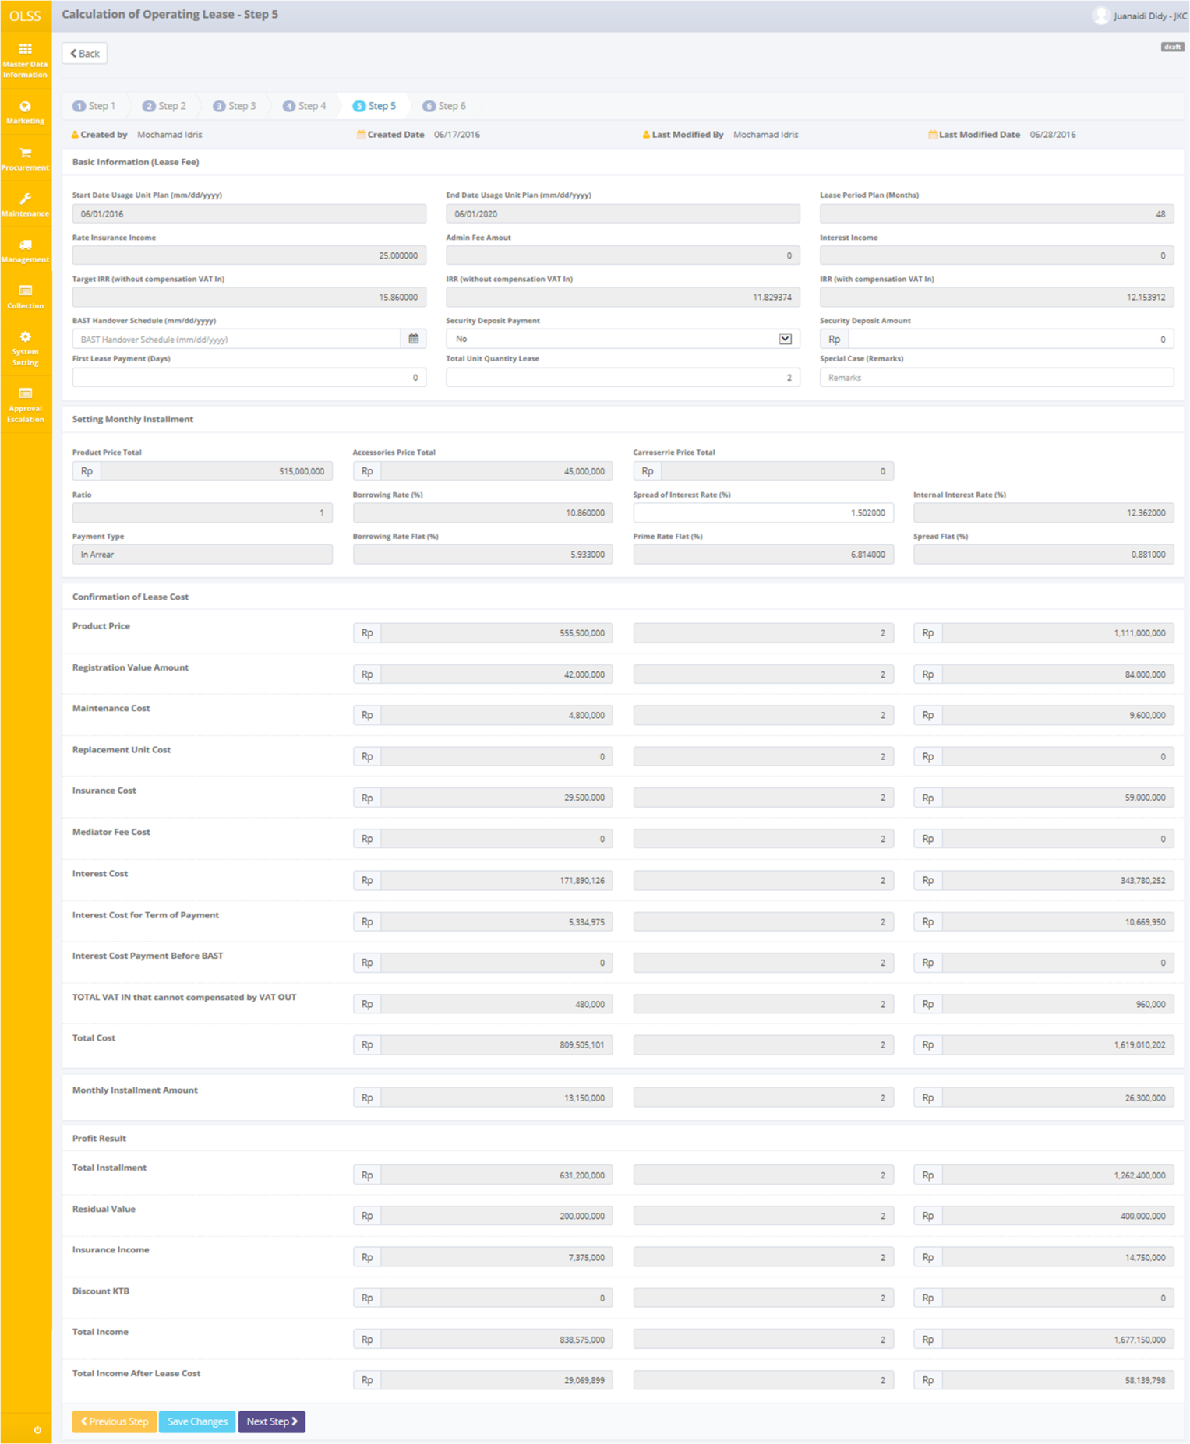

Screen 10: Screen of Create Calculation – Step 5

Once the calculation creation **Step 5** screen open, user has to fill information on the blank field. The fields are:

1. Basic Information (Lease Fee):
   1. BAST Handover Schedule (mm/dd/yyyy): select date of BAST handover schedule to customer.
   2. Security Deposit Payment: pick security deposit payment Yes or No.
   3. Security Deposit Amount: input amount of security deposit if you choose Yes in field Security Deposit Payment.
   4. First Lease Payment (Days): input days of first lease payment.
   5. Total Unit Quantity Lease: input total unit quantity lease.
   6. Special Case (Remarks): fill any special case.
2. Setting Monthly Installment:
   1. Spread of Interest Rate (%): to edit percentage of spread effective that has been inputted in step 2. Any changes in Step 5 will automatically change amount in Step 2.

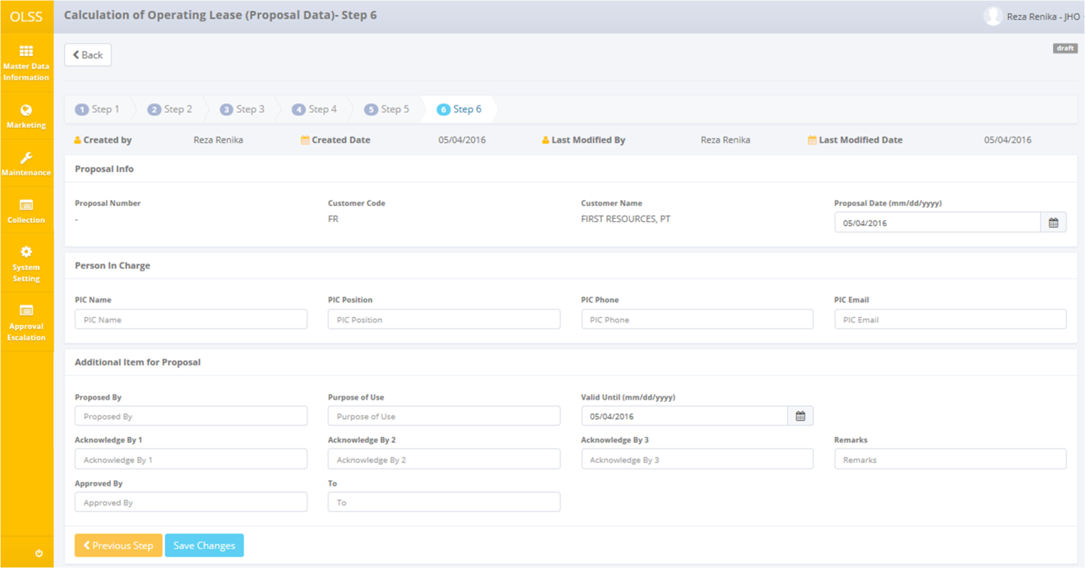

Screen 11: Screen of Create Calculation – Step 6

Once the calculation creation **Step 6** screen open, user has to fill information on the blank field. The fields are:

1. Proposal Info:
   1. Proposal Date: can update with select the date of proposal calculation. System automatically displays with current date.
2. Person In Charge:
   1. PIC Name: can update with input name (PIC name from DSF). System automatically displays with username.
   2. PIC Position: input job titles (PIC from DSF).
   3. PIC Phone: fill with phone number (PIC from DSF).
   4. PIC Email: input email addresses (PIC from DSF).
3. Additional Item for Proposal:
   1. Proposed By: input name who propose the proposal.
   2. Purpose of Use: input purpose of use to leasing the unit.
   3. Valid Until (mm/dd/yyyy): select the validation date of the proposal. System automatically displays with current date.
   4. Acknowledge By 1: input name who acknowledge the proposal.
   5. Acknowledge By 2: input the other name who acknowledge the proposal if any.
   6. Acknowledge By 3: input the other name who acknowledge the proposal if any.
   7. Remarks: fill with any information/remarks that needed.
   8. Approved By: input name that approved the proposal.
   9. To: fill with the proposal intended to whom.

There are six buttons that will be displayed on the create Calculation of Operating Lease screen as follows:

1. , on the top-left corner of the screen, to go to previous screen.
2. , on the bottom-left corner of the screen. Clicking this button will made calculation status changed into Draft.
3. 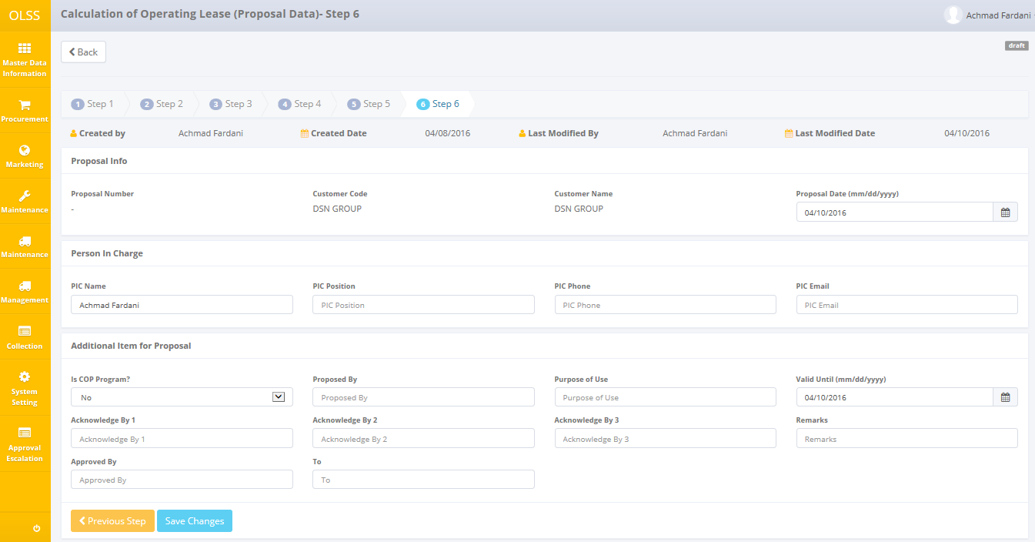, on the bottom-left corner of the screen. This button only displayed if the Save as Draft button has been clicked.
4. , on the bottom-left corner of the screen. Clicking this button will made calculation status changed into Submitted. This button only displayed on Step 6 and only displayed if the Save Changes button has been clicked.
5. , on the bottom-left corner of the screen, to go to previous step.
6. 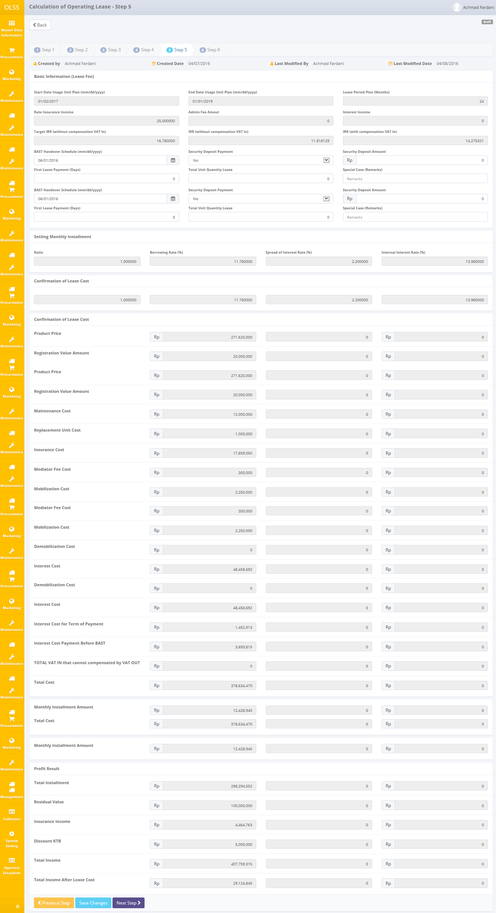, on the bottom-left corner of the screen, to go to next step. This button only displayed if the Save Changes button has been clicked.

After the data entered on the screen, user can save the information on the system by clicking **Save as Draft** button, then clicking **Save Changes** button if you fix with the data and want to continue the next process.

There are mandatory fields. It can’t leave as blanks. If you leave them blanks, system will notified it after you clicking **Save as Draft** or **Save Changes** button.

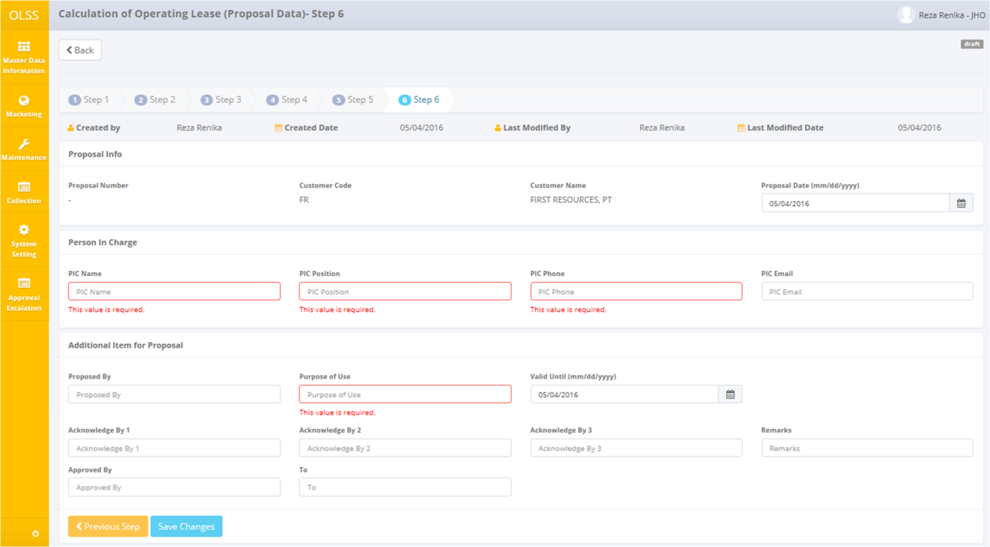

Screen 12: Error notification after Save as Draft/Save Changes

After clicking **Save as Draft**, **Save Changes,** and **Submit** button, system will notified if it success or failed to save data.



Screen 13: Success notification after Save as Draft



Screen 14: Success notification after Save Changes



Screen 15: Success notification after Submit

## Edit a Draft Document of Calculation

To edit calculation record, navigate to the Calculation of Operating Lease screen and click Edit button on the right side of the record with status  or .

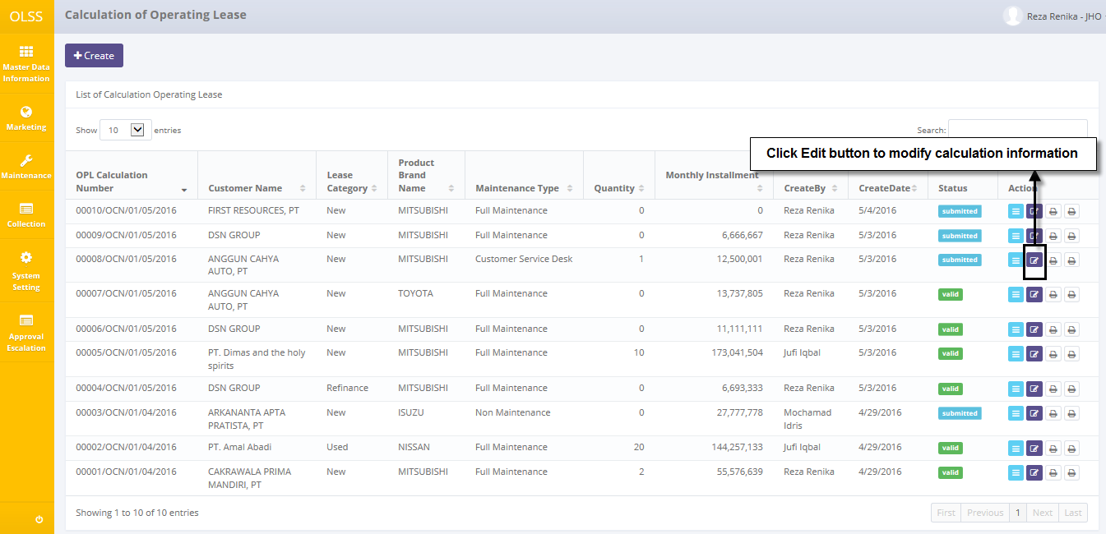

Screen 16: Navigate to Edit Calculation

The screen below is shown after the Edit button is clicked. System will displays the last step that you have been entered before.

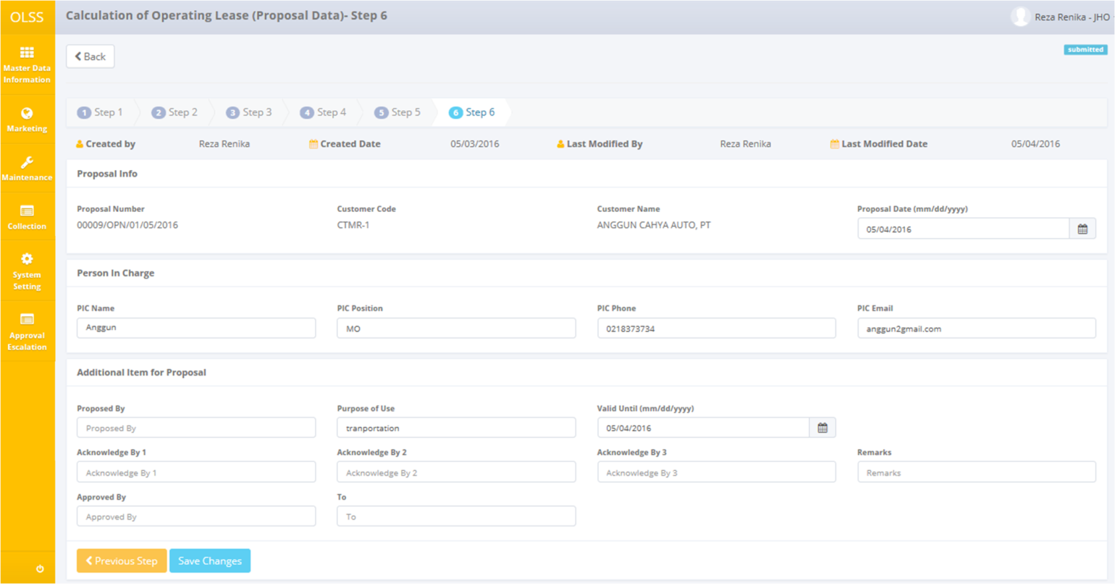

Screen 17: Screen of Edit Calculation

Once the Edit Calculation screens open, user can edit existed information. There are five buttons that will be displayed on the screen as follows:

1. , on the top-left corner of the screen, to go to previous screen.
2. , on the bottom-left corner of the screen.
3. , on the bottom-left corner of the screen. Clicking this button will made calculation status changed into Submitted. This button only displayed on Step 6.
4. , on the bottom-left corner of the screen, to go to previous step.
5. , on the bottom-left corner of the screen, to go to next step.

If data already changed on the screen, user can save data on the system by clicking **Save Changes** button, then click **Submit** button. There are mandatory fields. It can’t leave as blanks. If you leave them blanks, system will notified it after you clicking **Save Changes** button.

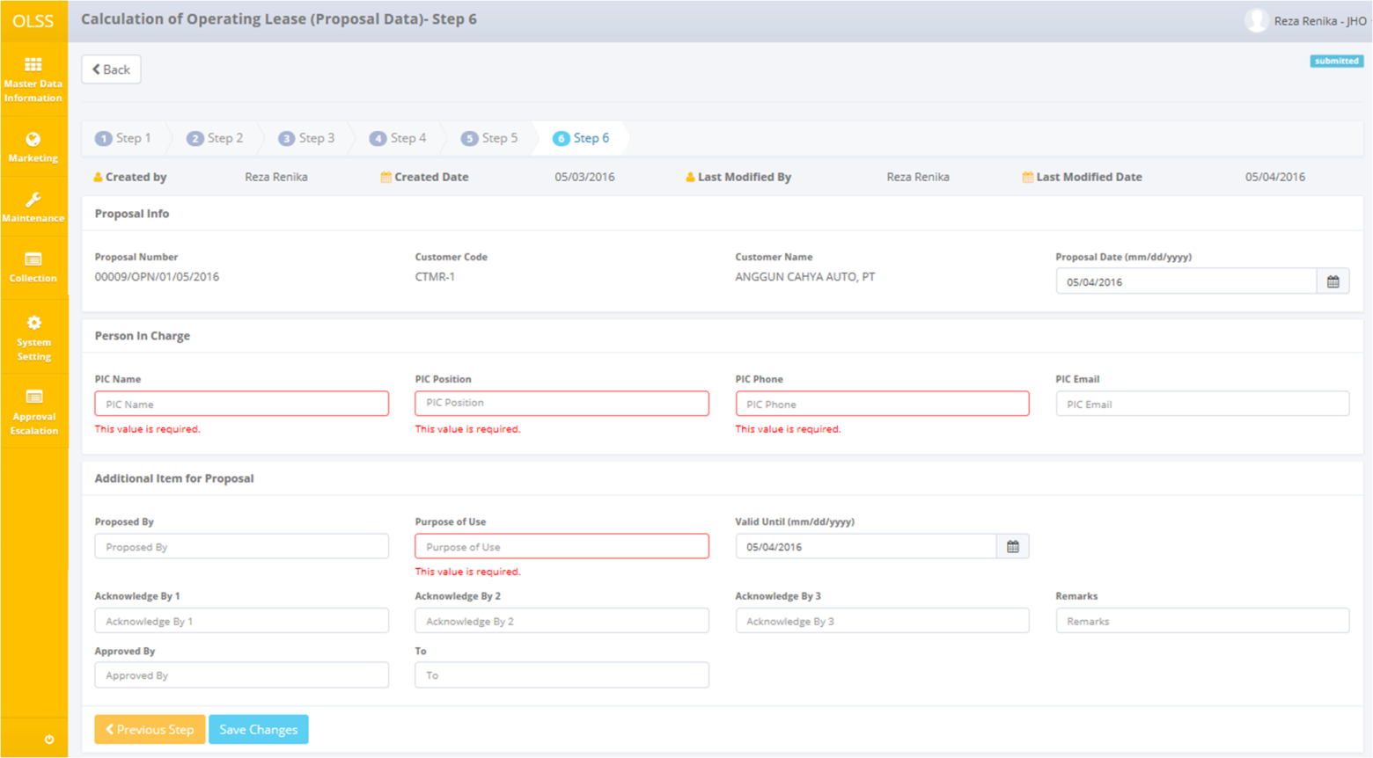

Screen 18: Error notification after Save Changes

After clicking **Save Changes** or **Submit** button, system will notified if it success or failed to save or submit a data. You also have a **Back** button, which redirect you to the previous page.



Screen 19: Success notification after Save Changes



Screen 20: Success notification after Submit

## View Detail Calculation of Operating Lease

To view the records, you can select a record from the list on Calculation of Operating Lease page by clicking the action button, on the rightmost column.

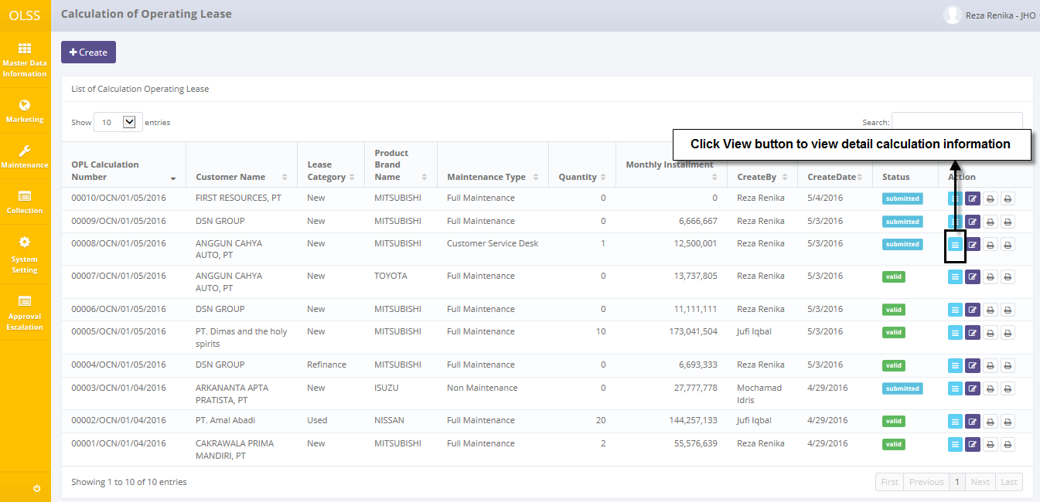

Screen 21: Navigate to View Detail Calculation

Screen will show view detail calculation screen shown below:

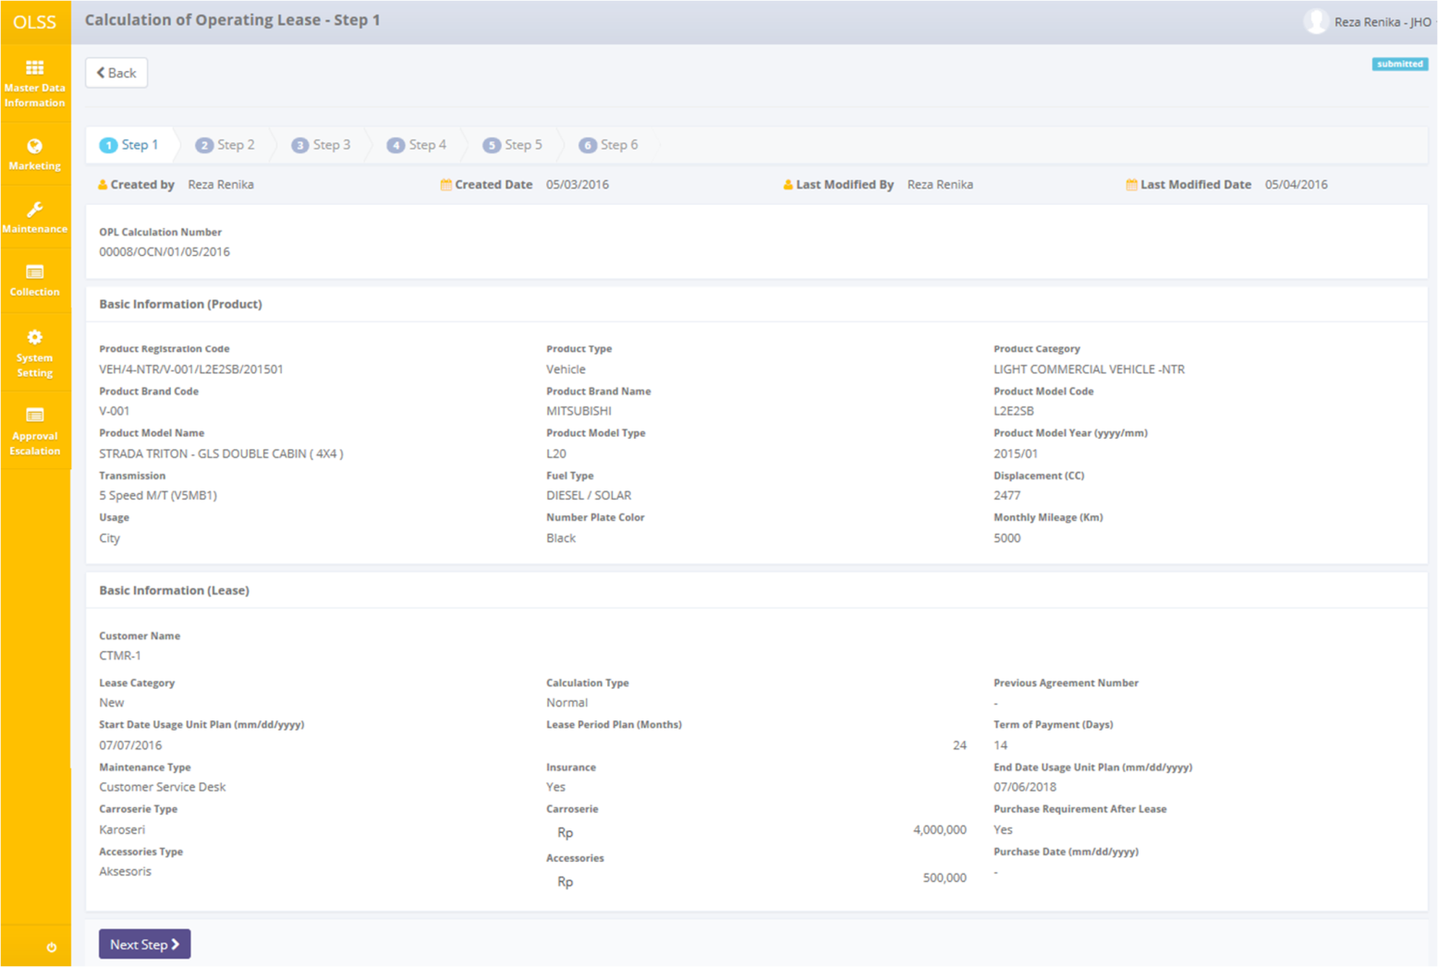

Screen 22: Screen View Detail Calculation – Step 1

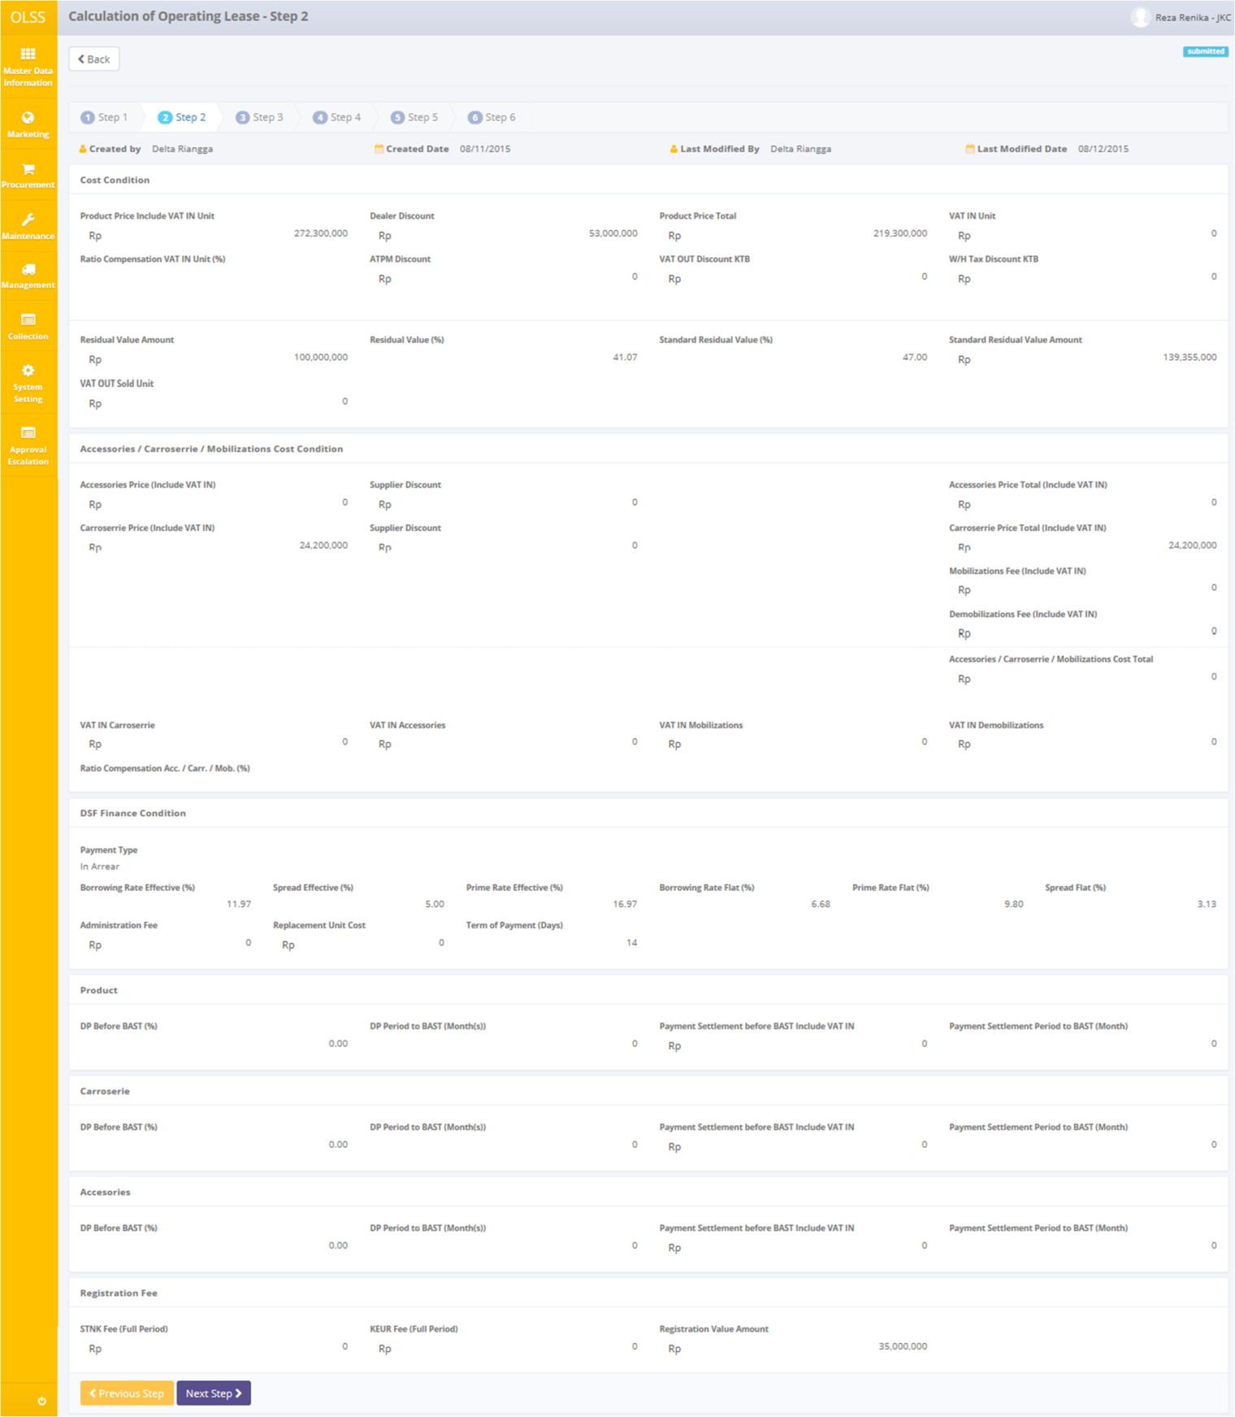

Screen 23: Screen View Detail Calculation – Step 2

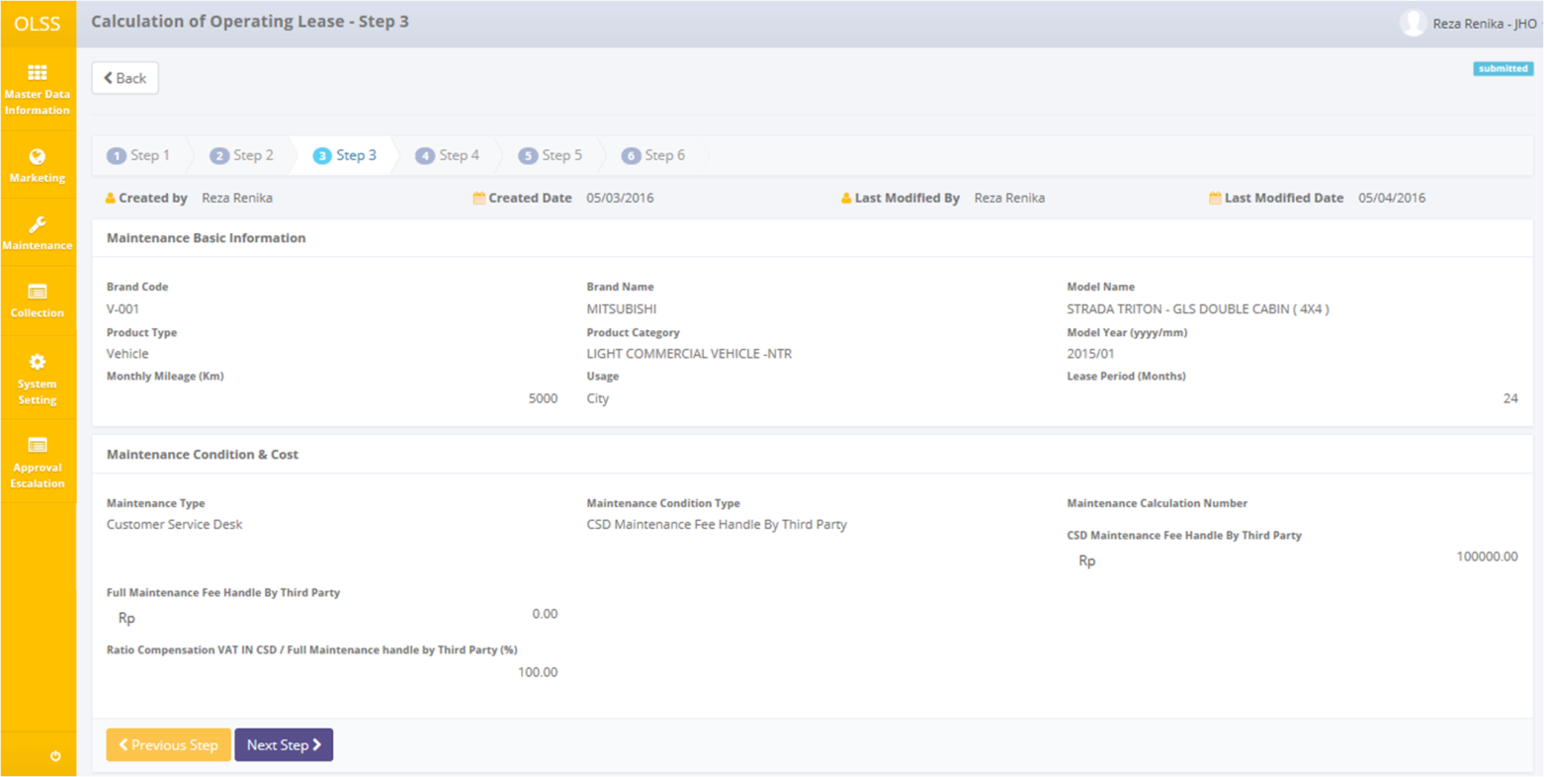

Screen 24: Screen View Detail Calculation – Step 3 (with maintenance)

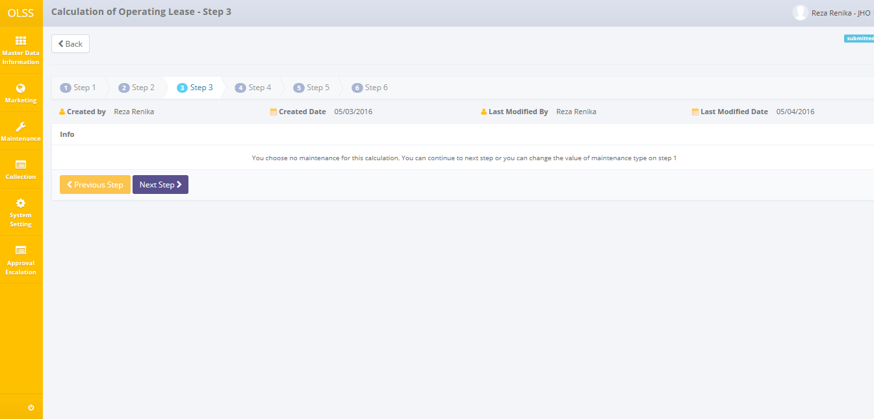

Screen 25: Screen View Detail Calculation – Step 3 (without maintenance)

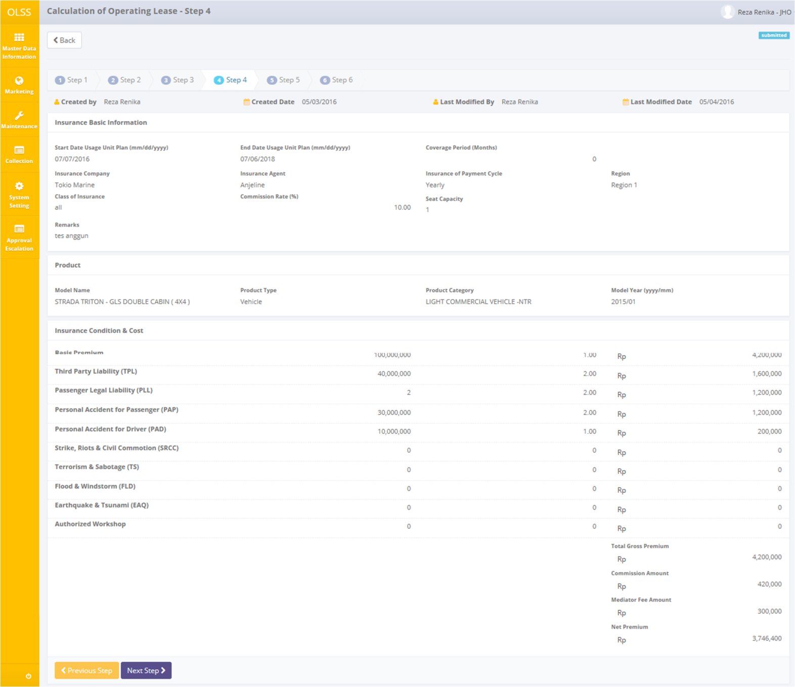

Screen 26: Screen View Detail Calculation – Step 4 (with insurance)

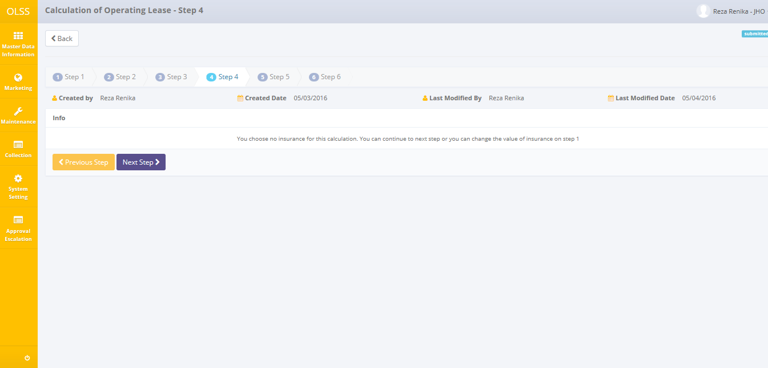

Screen 27: Screen View Detail Calculation – Step 4 (without insurance)

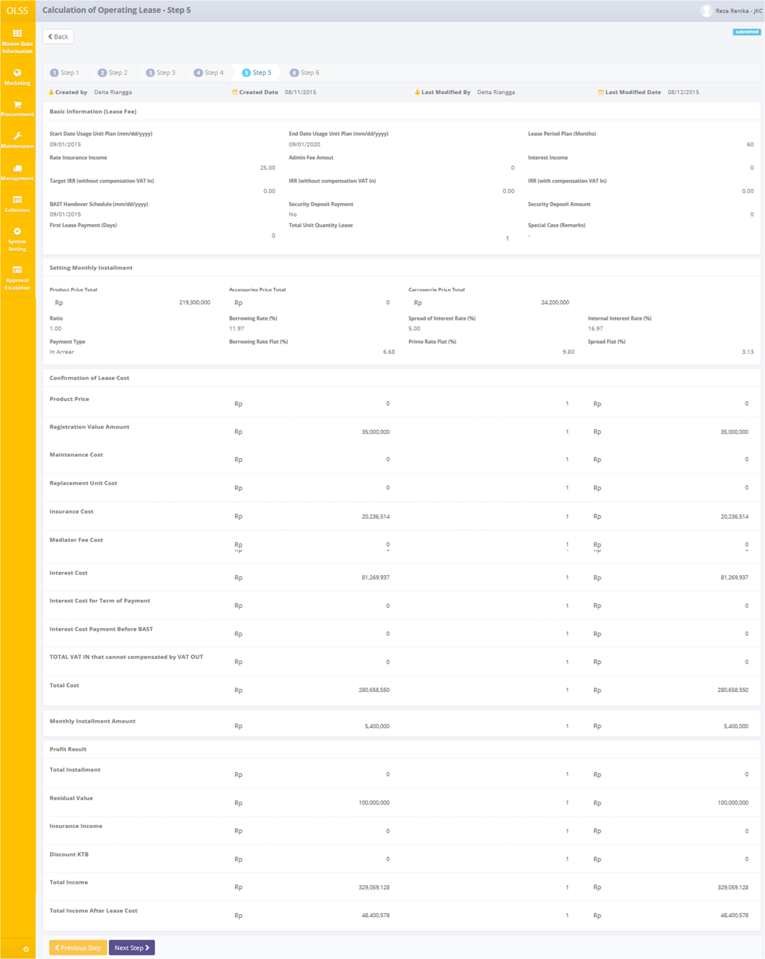

Screen 28: Screen View Detail Calculation – Step 5

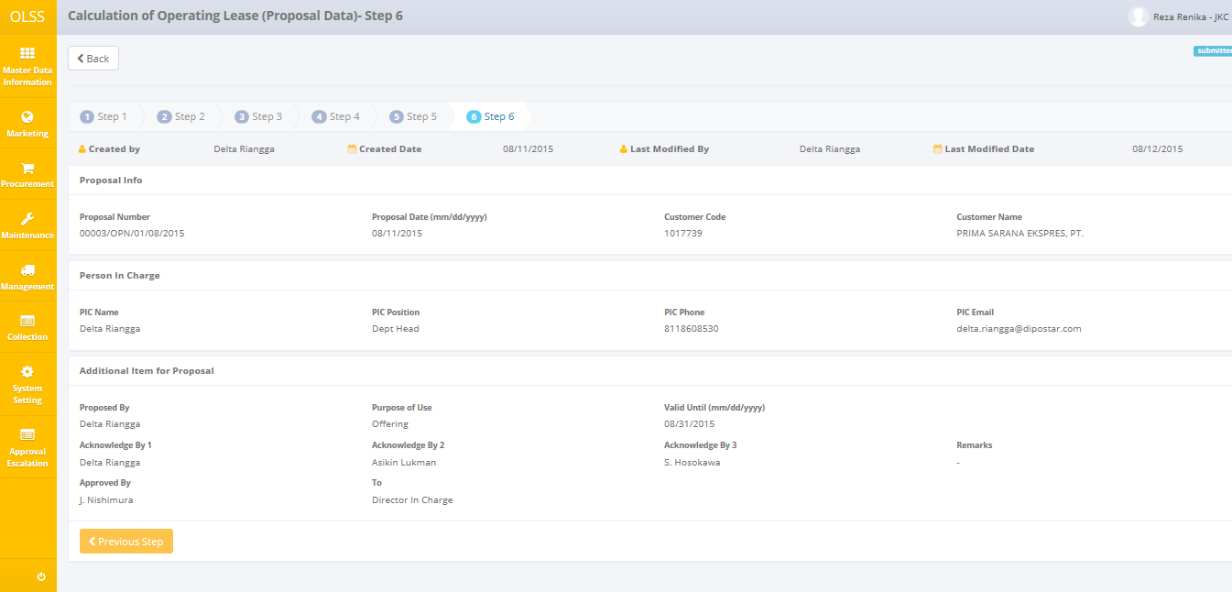

Screen 29: Screen View Detail Calculation – Step 6

User can check the records but the records cannot be clicked or edited. Here you can see the detail information related with Calculation Data from Step 1 until Step 6. There are five buttons that will be displayed on the screen as follows:

1. , on the top-left corner of the screen, to go to previous screen.
2. , on the bottom-left corner of the screen. Clicking this button will made calculation status changed into Submitted. This button only displayed on Step 6.
3. , on the bottom-left corner of the screen, to go to previous step.
4. , on the bottom-left corner of the screen, to go to next step.

## Print Proposal Report

Aside from printing proposal report, user can print the entire proposal report that has been recorded in the database. To print the report, user can click Print button on the rightmost column.

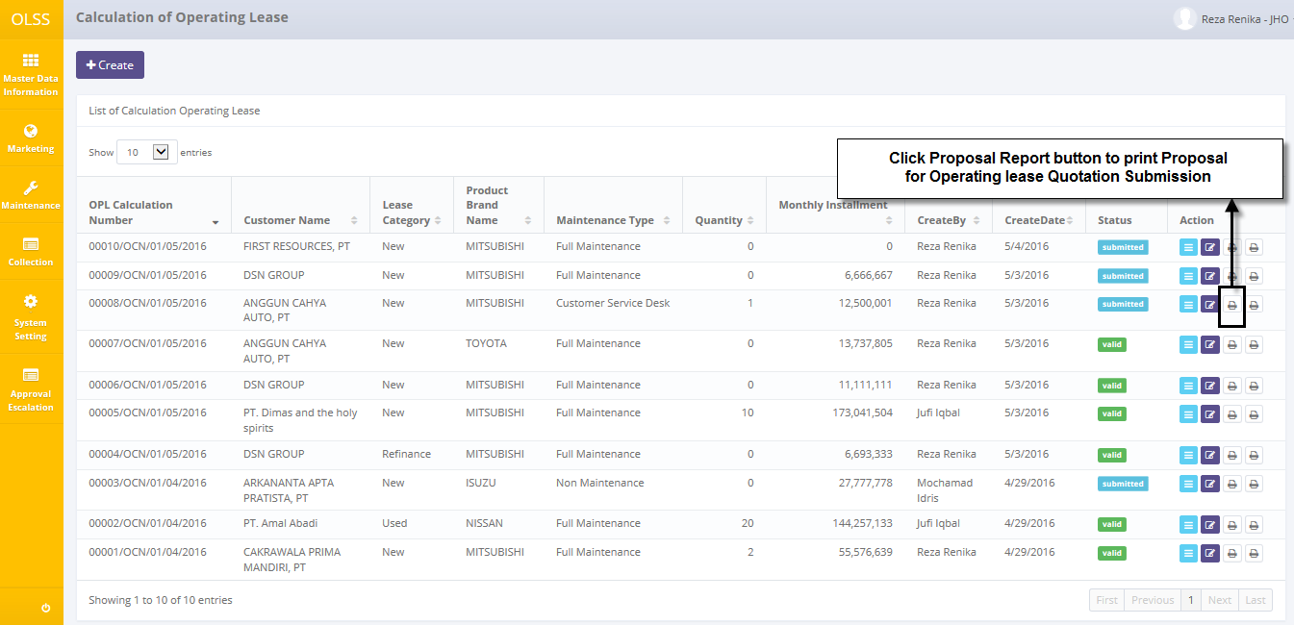

Screen 30: Navigate to Print Proposal Report

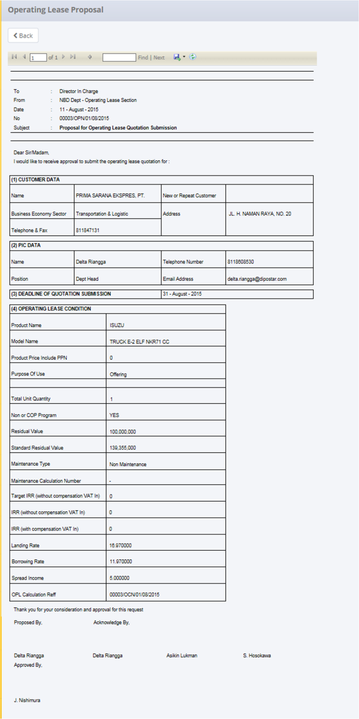

Screen 31: Preview Proposal Report

## Print Calculation Attachment Report

Aside from printing calculation attachment report, user can print the entire calculation attachment report that has been recorded in the database. To print the report, user can click Print button on the rightmost column.

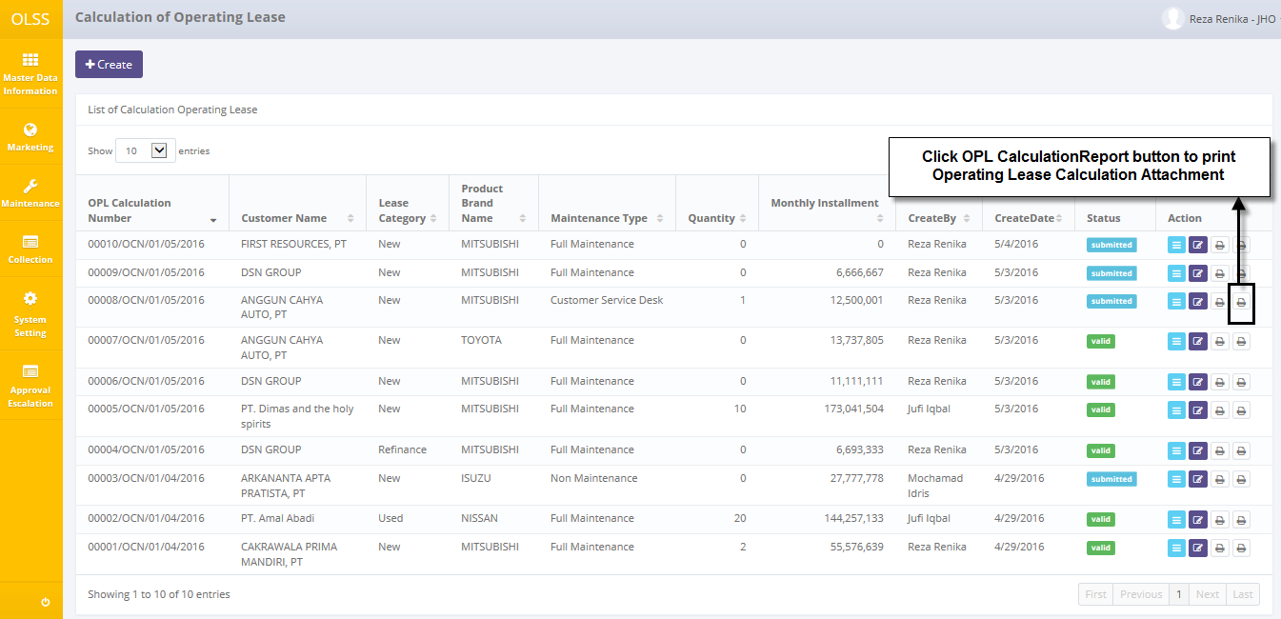

Screen 32: Navigate to Print Calculation Attachment Report

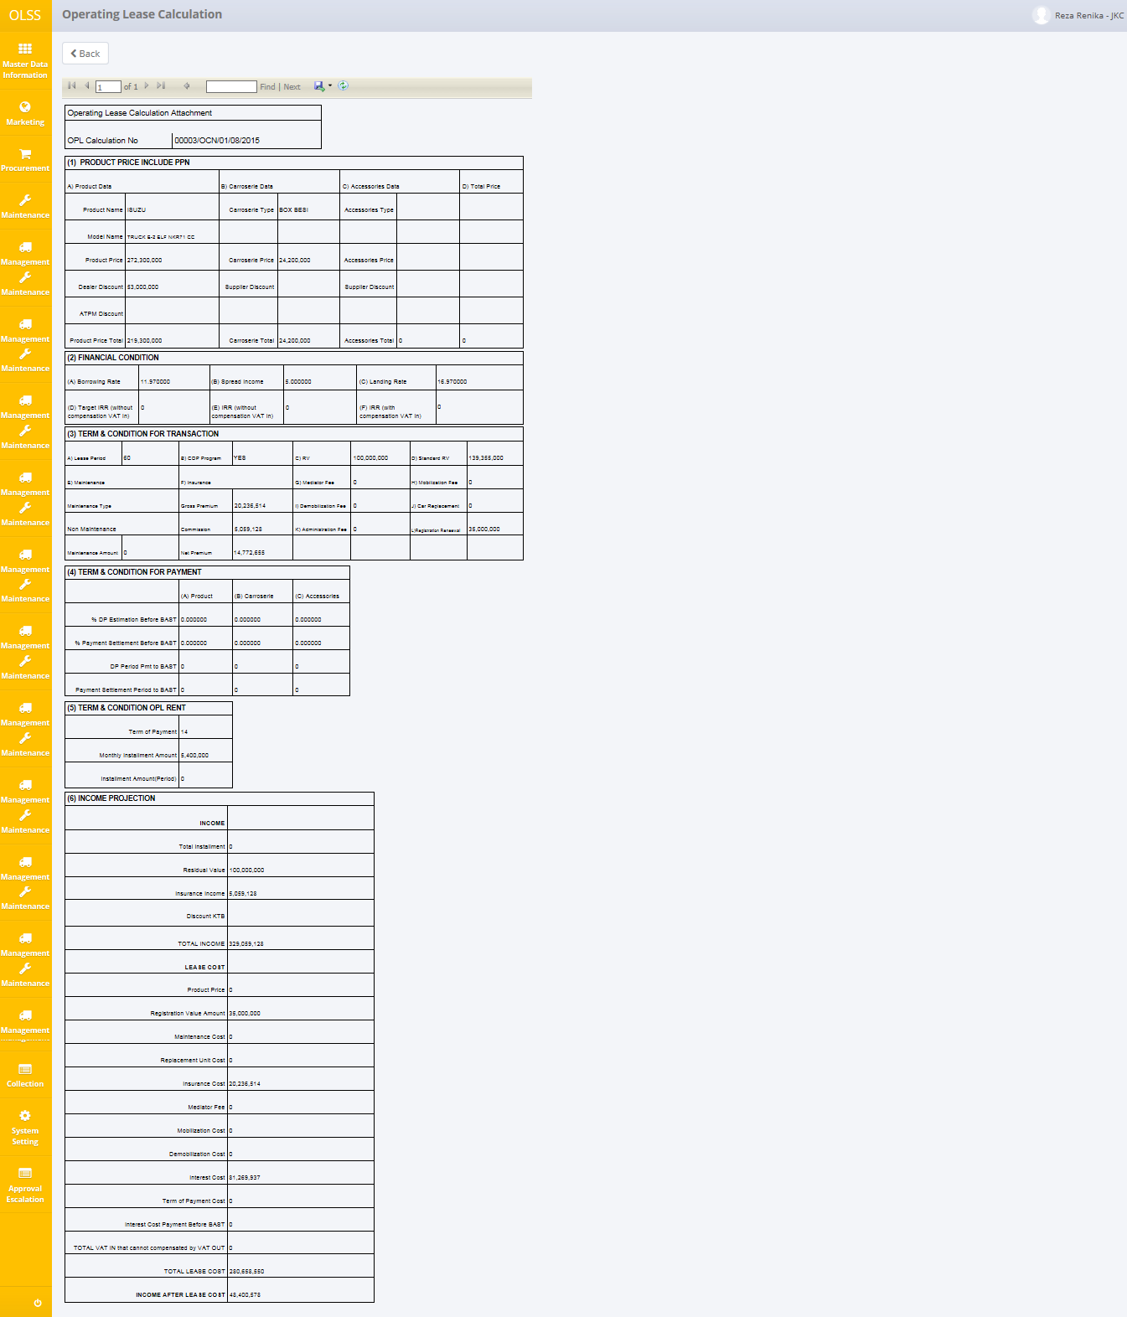

Screen 33: Preview Calculation Attachment Report